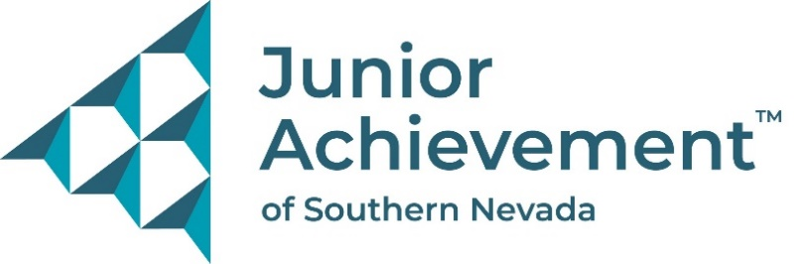
Date:
FOR IMMEDIATE RELEASE:
https://www.dropbox.com/scl/fo/i0u6vwc92mhudu8vjb3ws/AJfqFUAY2qOl42ZTFtQ1cY4?rlkey=3rxd7rjp1racgslur3ofcquoc&st=ik12euip&dl=0

New Summer Camp Offers Fun Way to Learn about the “Business of Life”
Junior Achievement of Southern Nevada Launches
“Finding My Future” Summer Camps

LAS VEGAS – Junior Achievement of Southern Nevada (JASN) is inviting youth to participate in its first-ever Finding My Future Summer Camp, hosted at the financial literacy nonprofit organization’s newly opened JA Inspiration Center. The week-long camp blends the organization’s two signature programs, Betty’s JA BizTown and JA Finance Park, into a dynamic, hands-on, educational and entertaining summer experience. Even students who’ve participated in one of the programs during the school year will experience something new.
Finding My Future Summer Camp is more than just fun – it’s a launchpad for skills that will last a lifetime. Youth will explore real-world scenarios where they learn how to earn, spend, save, and even run a business.
This unique camp experience empowers youth with tools and confidence to take charge of their future through a mix of interactive learning and exciting challenges in two different “cities” with various stores, utilities, banks, municipalities and more.
Campers will:
- Explore real careers
- Learn how to budget and manage money
- Launch their own business
- Build leadership, teamwork, and critical thinking skills
- Have fun while planning for their future
“Since opening our JA Inspiration Center, the response has been overwhelming, not only from schools but also from our sponsors, volunteers, board members and staff,” said Michelle Jackson, president and CEO of Junior Achievement of Southern Nevada. “Everyone has asked how their children could experience Betty’s JA BizTown and JA Finance Park, even if they didn’t participate in these programs during the regular school year. We created this camp to meet that demand while providing a safe, educational environment during summer break for all local kids.”
Finding My Future Summer Camp is open to students entering grades 4 – 9. Each session runs from 8 a.m. – 2 p.m., Monday through Friday, and is available on the following dates:
- May 27 – 30
- June 2 – 6
- July 21 – 25
- July 28 – August 1
The camp takes place at the Junior Achievement Inspiration Center, located at 4440 E. Tropicana Ave., Las Vegas, NV 89121.
Registration is $275 per youth, or $300 with lunch provided by JASN.
To learn more, visit FINDING MY FUTURE SUMMER CAMP | Junior Achievement of Southern Nevada
To register visit Junior Achievement Inspiration Center Summer Camp 2025
For questions, email jasn.education@ja.org or call 702-214-0500.

About Junior Achievement of Southern Nevada
Founded locally in 1996, Junior Achievement of Southern Nevada, Inc. is dedicated to providing financial education to K-12 students and young adults with a curriculum including wants vs. needs, budget management to economic principals, workforce skills, credit and entrepreneurship. The completion of the new 40,000-square-foot Junior Achievement of Southern Nevada Inspiration Center will allow the nonprofit organization to impact more than 60,000 local youth. It is now the permanent site for capstone programs, Betty’s JA BizTown and JA Finance Park. Junior Achievement of Southern Nevada’s financial literacy mission is accomplished with the support of 285 businesses and 6,800 business role models, who help youth learn about the “business of life,” by helping bridge the gap between what youth learn in school and the real world. For more information visit https://jasnv.org/ and follow on Instagram and Facebook.

# # #

